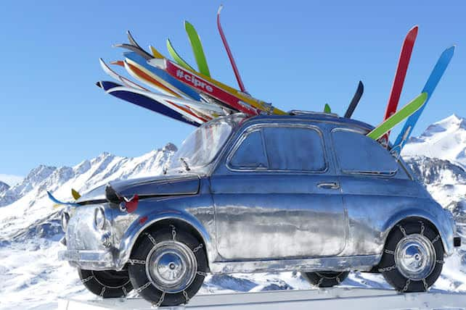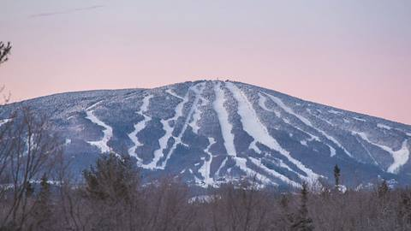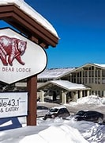

Stratton, Vermont
March 7-10, 2026
$399 per person/double occupancy

This will be a drive-up trip. Gather your friends, load your car, and join KOPSC for a fun weekend in Stratton! Sign up for a great trip.
Stratton is the highest peak in southern Vermont and has 670 acres of ski terrain. Of the 670 acres, 160 acres include glade skiing. With ninety-nine skiing trails, there is a variety of skiing for everyone from novice to experts. We will be staying at the Black Bear lodge that is close to the base of the mountain. The lodge contains amenities that will provide additional enjoyment. We will be driving up Saturday and departing after skiing on Tuesday to take advantage of less traffic for the drive and a less crowded mountain. Please note: the lift tickets are not included in the price. Here are the prices: Sunday-$117/day, Monday and Tuesday, $96/day, or $192/ 2 days. IKON pass holders will pay the stated price.

Payment Schedule:
- $133 deposit due at signup
- $133 due 10/15/24
- $133 due 12/17/24

Trip Includes:
- 3 nights lodging at the Black Bear Lodge
- Group Dinner
- Daily Breakfasts
- Lots of fun!

To sign up, send deposit check made payable to KOPSC, a signed registration/release form, and a copy of your driver’s license to,
Dave Mertz
210 Whitestone Dr.
Kennett Square, PA 19348
dmertz000@icloud.com

